

JOGU

Software Requirements Specification

Version 1.2

December 14, 2016

José Esteves
Ricardo Malafaya

Prepared for ERMS - Requirements Engineering and Software Modeling, FEUP, 2016



Table of Contents

Table of Contents i
List of Figures ii
Revision History ii
Document Approval ii
1.0. Introduction 2
1.1. Purpose 2
1.2. Scope of Project 2
1.3. Goals 3
1.4. Glossary 3
1.4. References 4
1.5. Stakeholders 4
1.5. Overview of Document 4
2.0. Overall Description 6
2.1 System Environment 6
2.2 Functional Requirements Specification 7
2.2.1 User Login Use Case 7
Use case: UC0 - User Login 7
2.2.2 User Manages Groups Use Case 8
Use case: UC1.1 - User Manages Group 8
Use case: UC1.2 - User Accepts Invitation 8
Use case: UC1.3 - Admin Adds Event to Group 9
Scenario: S1 - User Invites Friends to Events #TBD# 9
2.2.3 User Manages Events Use Case 11
Use case: UC2.1 - User Manages Event 11
Scenario: S2 - User Creates Game Events #TBD# 11
2.2.4 User Manages Stats Use Case 13
Use case: UC3.1 - User Adds Stat to Event 13
Use case: UC3.2 - User Manages Stat 13
Scenario: S3 - Publishes Game Stats #TBD# 14
2.2.5 Overall Scenario 16
Scenario: S0 – Overall Scenario #TBD# 16
2.3 Actors and roles 17
2.4 Non-Functional Requirements 17
3.0. Requirements Specification 18
3.1 External Interface Requirements 18
3.2 Functional Requirements 18
3.2.1 R0.1 - User Login 18
3.2.2 R0.2 - User Registers 18
3.2.3 R1.1 - User Creates Group 19
3.2.4 R1.2 - User Checks Group 19
3.2.5 R1.3 - Admin Edits Group 19
3.2.6 R1.4 - User Accepts Invitation 20
3.2.7 R1.5 - Admin Adds Event to Group 20
3.2.8 R2.1 - User Creates Event 21
3.2.9 R2.2 - User Checks Event 21
3.2.10 R2.3 - Admin Edit Event 21
3.2.11 R3.1 – User Adds Stat to Event 22
3.2.12 R3.2 – User Checks Stats 22
3.2.13 R3.3 – Admin Edits Stats 22
3.3 Detailed Non-Functional Requirements 23
3.3.1 Logical Structure of the Data 23
3.3.2 Security 24
A. Appendices 1
A.1 Activity Diagram 1
A.2 Class Diagram 2
A.3 State Diagram 3
A.4 Dependency Matrix 4
A.5 Requirements and their attributes 5

List of Figures

Figure 1 - System Environment 4
Figure 2 - Article Submission Process 6
Figure 3 - Editor Use Cases 8
Figure 4 - Logical Structure of the Article Manager Data 23

Revision History

Date | Description | Author | Comments
2016-11-10 | Iteration 0 - First draft | J&R | Version 1.1
2016-11-11 | Iteration 1 - PO Modifications | J&R | Version 1.2
2016-12-07 | Iteration 2 | J&R | Version 1.3
2016-12-14 | Final – Structure Reformulated | J&R | Version 2.0

Document Approval

The following Software Requirements Specification has been accepted and approved by the following:
Signature | Printed Name | Title | Date
 | <Your Name>

1.0. Introduction

1.1. Purpose
The purpose of this document is to present a detailed description of the Web Social Football amateur system. It will explain the purpose and features of the system, the interfaces of the system, what the system will do, the constraints under which it must operate and how the system will react to external stimuli. This document is intended for both the stakeholders and the developers of the system.
The software JOGU is a mobile platform where football amateur players can share experiences. The users of this application can create football games, called events, and invite other users to join and create a game. This app permit to share live goals, attendance and results of each event. Each player can also check past games, goals and statistics.

1.2. Scope of Project
This software system will be a mobile platform where football amateur players can share experiences called SOGU. The system will be design the facilitate the management of large groups of friends that have scheduled game events.
The users of this application can create football games, called events, and invite other users to join and create a game. More specifically, this system is designed to allow the user to create and share events with a group of friends and share live goals, attendance and results of each event. Each user will be able to check the score of past events and consult statistics about them self’s.

1.3. Goals
This software is a platform of share experience of the amateur football players. The user can create events. To each event, other users can be invited and attend. After the users confirm that they will attend the event, the teams are made. All the participants of the event can share stats of the event. The creator of the event is set as an administrator of that event and can overwrite any stat publish by the attendees. The administrator can attribute administrator’s permissions to other users on the event.
Each user can connect to application through login and access their own stats.
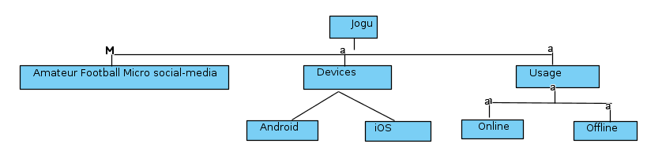
This application is targeting mobile devices (Android and IOS). To publish stats the application needs access to internet but also will permit to consult the stats offline.
Figure 1 - Goals And/Or diagram

1.4. Glossary
Term | Definition
User | Any amateur football player that use the application to create events, attend to events or check stats.
Event | Is a meeting created by the users which users can attend with the information about the time and the place where the amateur football game will be taking place.
Administrator | In case of incorrect stats, the administrator is the user with the permission to alter the stats publish by the users.
Super Administrator | Person of developing team charged to intervene in case of failure.
Group | A list of users. A group can be associated to several events.
Stats | Published information that can be goals, attendance or final score of the event
Team | At event, the participants are divided in to groups.
Invitation | An invitation send by the creator of the event. The users can accept this invitation
Statistics | Information that the user can access about the events, goals, results and attendance of past events.

1.4. References
IEEE. IEEE Std 830-1998 IEEE Recommended Practice for Software Requirements Specifications. IEEE Computer Society, 1998.

1.5. Stakeholders
The relevant stakeholder of this application are the product owner, the group of developers and the people that will use the app, both those who interact with its features and users as well as the users who are just viewing and exploring the displayed information.

1.5. Overview of Document
The next chapters, the Overall Description section, of this document gives an overview of the functionality of the product. It describes the informal requirements and is used to establish a context for the technical requirements specification in the next chapter.
The third chapter, Requirements Specification section, of this document is written primarily for the developers and describes in technical terms the details of the functionality of the product.
Both sections of the document describe the same software product in its entirety, but are intended for different audiences and thus use different language.
This table represent the relations between goals (section 1.3), user cases (section 2.2) and requirements (section 3.2):
ID | Goals | ID | Use Cases |  | Requirements
 |  | UC0 | User Login | R0.1 | User Login
 |  | UC0 | User Login | R0.2 | User Register
G1 | User Invites Friends to Events | UC1.1 | User Manages Group | R1.1 | User Creates Groups
 |  |  |  | R1.2 | User Checks Group
 |  |  |  | R1.3 | Admin Edits Group
G1 | User Invites Friends to Events | UC1.2 | User Accepts Invitation | R1.4 | User Accepts Invitation
G1 | User Invites Friends to Events | UC1.3 | Admin Adds Event to Group | R1.5 | Admin Adds Event to Group
G2 | User Creates Game Events | UC2.1 | User Manages Event | R2.1 | User Creates Event
 |  |  |  | R2.2 | User Checks Event
 |  |  |  | R2.3 | Admin Edit Event
G3 | User Publishes Game Stats | UC3.1 | User Adds Stat to Event | R3.1 | User Adds Stat to Event
G3 | User Publishes Game Stats | UC3.2 | User Manages Stat | R3.2 | User Check Stat
 |  |  |  | R3.3 | Admin Edits Stat

2.0. Overall Description

2.1 System Environment
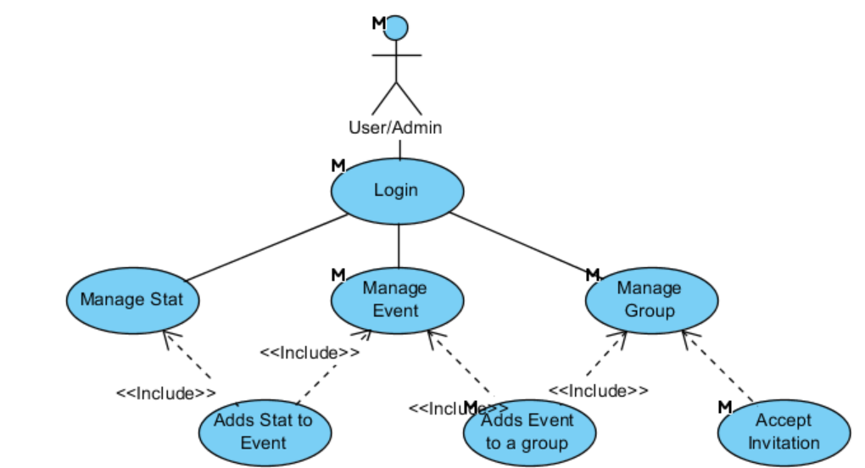
Figure 2 - System Environment

#TBD# The Web Publishing System has four active actors and one cooperating system.
The Author, Reader, or Reviewer accesses the Online Journal through the Internet. Any Author or Reviewer communication with the system is through email. The Editor accesses the entire system directly. There is a link to the (existing) Historical Society.#TBD#

2.2 Functional Requirements Specification

2.2.1 User Login Use Case

Use case: UC0 - User Login
Diagram:
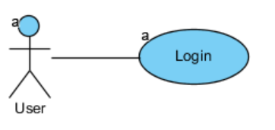
Brief Description
The user can login into the system with email and password. If the user is not registered in system, he can register a new account.

Initial Step-By-Step Description
The first interaction between the user and the application. The login will appear on the launch of the App.

- The user selects login method: email and password or Google account or Facebook account.
- The user inserts credentials.
- After confirmation, the system will show the main app window.

Xref:
Goals: G1 + G2
Requirements: R0.1 + R0.2
Mock: M0

2.2.2 User Manages Groups Use Case

Use case: UC1.1 - User Manages Group
Diagram:
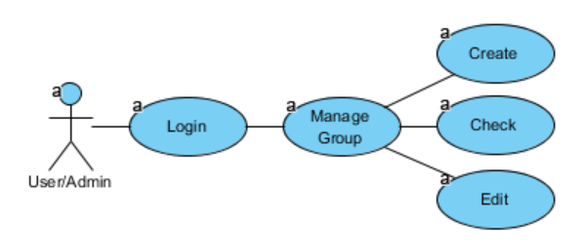
Brief Description
The user creates a group by adding users by inputting an email. Every user in the group can consult but only the user with administrator permissions can edit it.

Initial Step-By-Step Description
Before user create a group, has to be login on system.

- The user on “Main Page” can select a group on the group’s list or select the add sign to create a new one.
- The system redirects to the “Group page”.
- If the user is admin, he can select the group name to alters it, can add admin permissions to users or select the add sign to send invites to other users.
- All the users that already accept an invite will show on the list.

Xref:
Goals: G1
Requirements: R1.1 + R1.2 + R1.3
Mock: M1 + M2

Use case: UC1.2 - User Accepts Invitation
Diagram:
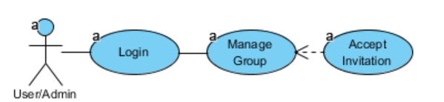
Brief Description
The user can receive invitations to enter in other group

Initial Step-By-Step Description
As soon as the author of the user add a friend user to a group. This user will receive an invitation by email.

- The user selects the link send by email.
- The system automatically adds the user to the group of the invitation.

Xref:
Goals: G1
Requirements: R1.4

Use case: UC1.3 - Admin Adds Event to Group
Diagram:
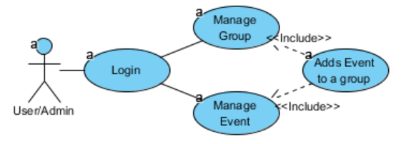
Brief Description
After the group is made, the administrator can add new events.

Initial Step-By-Step Description

- From the “Main Page” the user selects the group that wants to add an Event.
- The System will show the “Group Page”
- The user selects option “Add Event”
- The system list all the events without group and an option to create a new one.

Xref:
Goals: G1 + G2
Requirements: R1.5
Mock: M1

Scenario: S1 - User Invites Friends to Events #TBD#
Diagram:
Brief Description
The user can login into the system with email and password. If the user is not registered in system, he can register a new account.

Initial Step-By-Step Description
The first interaction between the user and the application. The login will appear on the launch of the App.

- The user selects login method: email and password or Google account or Facebook account.
- The user inserts credentials.
- After confirmation, the system will show the main app window.

Xref:
Goals: G1 + G2
Requirements: R0.1 + R0.2
Mock: M1

2.2.3 User Manages Events Use Case

Use case: UC2.1 - User Manages Event
Diagram:
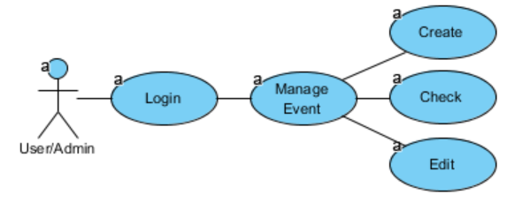
Brief Description
The user creates an event. Every event has an associated group. Each user of the associated group, can check the event. Only the users with administrator permissions can edit the event.

Initial Step-By-Step Description
Before user create an event, has to be login on system.

- From the “Main Page”, the user can select an event on the event’s list and system redirects to the “Event page” that will show the date, location, teams and final score of the event.
- If the user is admin, he can:
  - Select modify the date, location and team dispositions of the event.
  - Create a new event from the Group page.

Xref:
Goals: G2
Requirements: R2.1 + R2.2 + R2.3
Mock: M3

Scenario: S2 - User Creates Game Events #TBD#
Diagram:
Brief Description
The user can login into the system with email and password. If the user is not registered in system, he can register a new account.

Initial Step-By-Step Description
The first interaction between the user and the application. The login will appear on the launch of the App.

- The user selects login method: email and password or Google account or Facebook account.
- The user inserts credentials.
- After confirmation, the system will show the main app window.

Xref:
Goals: G1 + G2
Requirements: R0.1 + R0.2
Mock: M1

2.2.4 User Manages Stats Use Case

Use case: UC3.1 - User Adds Stat to Event
Diagram:
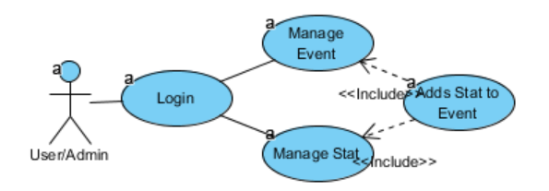
Brief Description
After the event is made, the users can add stats to it. The users can access the event and add stats to it.

Initial Step-By-Step Description

- From the “Main Page” the user selects the event that wants to add an Stat.
- The System will show the “Event Page”
- The user selects option “Add Stat”
- The system will redirect to the “Stat Page”.
- The user enters the author of the stats and the stat info.

Xref:
Goals: G1 + G2
Requirements: R3.1
Mock: M3

Use case: UC3.2 - User Manages Stat
Diagram:
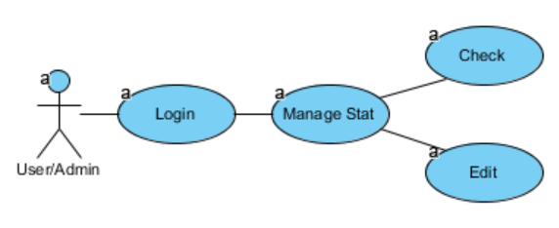
Brief Description
The user can check the stats associated to him or the stats associated with an event. If the user has administrator permissions on the group associated with the event that contain the stat, then he can edit it.

Initial Step-By-Step Description
Before user manage a stat, has to be login on system.

- The user selects the Stats from the “Main Page”
- The system will show the list of all the stats which the user is involved.
- If the user has admin permission over the stats, he can change it by clicking on it.

Alternative

- The user selects the Event from the “Main Page”
- The system will show the “Event Page”, and the list of all the stats related to that Event.
- If the user has admin permission over the stats, he can change it by clicking on it.

Xref:
Goals: G1 + G2
Requirements: R3.2 + R3.3
Mock: M4 + M3

Scenario: S3 - Publishes Game Stats #TBD#
Diagram:
Brief Description
The user can login into the system with email and password. If the user is not registered in system, he can register a new account.

Initial Step-By-Step Description
The first interaction between the user and the application. The login will appear on the launch of the App.

- The user selects login method: email and password or Google account or Facebook account.
- The user inserts credentials.
- After confirmation, the system will show the main app window.

Xref:
Goals: G1 + G2
Requirements: R0.1 + R0.2
Mock: M1

2.2.5 Overall Scenario

Scenario: S0 – Overall Scenario #TBD#
Diagram:
Brief Description
The user can login into the system with email and password. If the user is not registered in system, he can register a new account.

Initial Step-By-Step Description
The first interaction between the user and the application. The login will appear on the launch of the App.

- The user selects login method: email and password or Google account or Facebook account.
- The user inserts credentials.
- After confirmation, the system will show the main app window.

Xref:
Goals: G1 + G2
Requirements: R0.1 + R0.2
Mock: M1

2.3 Actors and roles
The JOGU has two active actors.
The User and the Administrator. The Administrator is a user with more permissions. Any user can only access the applications through login. The login can be by email and password or using the social session of Google or Facebook.
The user is expected to create and consult events, check results and publish stats.
The administrator is expected to change any incorrect stat of an event. By default, user that creates an event is automatically assign as its administrator. The administrator can grant permissions to other users in the event.

2.4 Non-Functional Requirements
The JOGU will be on a server with high speed Internet capability. The physical machine to be used will be determined by the product owner. The software developed here assumes the use of a tool such as Tomcat for connection between the app and the database. The speed of the app’s connection will depend on the hardware used rather than characteristics of this system.

3.0. Requirements Specification

3.1 External Interface Requirements
This project does not have external interfaces. Thus, section not applicable.

3.2 Functional Requirements
The Logical Structure of the Data is contained in Section 3.3.1.

3.2.1 R0.1 - User Login
Use Case Name | UC0 - User Login
XRef | Section 2.2.1, UC0 - User Login  Mock M0
Trigger | The user opens application
Precondition | The user has not yet logon on application
Basic Path | - The user opens the application  - The system displays login by email, Google or Facebook.  - The user has to choose the login type and enter the credentials.  - The system will check if the credentials are correct  - The main window of the app is shown
Alternative Paths | In step 2., if user already logon on app go to 5.
Postcondition | User enters main page
Exception Paths | If credentials are not correct, shows a error message.
Other | None

3.2.2 R0.2 - User Registers
Use Case Name | UC0 - User Login
XRef | Section 2.2.1, UC0 - User Login  Mock M0
Trigger | The user opens application
Precondition | The user has not yet logon on application
Basic Path | - The user opens the application  - The system displays login by email, Google or Facebook.  - The user enters the credentials and selects Register.  - The system will send a verification email to user.  - The system shows a message to the user verify the email.  - System hangs until confirmation of email and proceeds.  - System verify invitations (See 3.2.6 R1.4 - User Accepts Invitation)
Alternative Paths | None.
Postcondition | The database has been updated.
Exception Paths | In case of no internet, the system message user that cannot proceed without internet
Other | None

3.2.3 R1.1 - User Creates Group
Use Case Name | UC1.1 - User Manages Group
XRef | Section 2.2.2, UC1.1 - User Manages Group  Mock M1, M2
Trigger | The user selects the option “Create a Group” from Main page
Precondition | The user has already logon on system
Basic Path | - The user selects the users to add (from past events) or inputs the other users email.  - The system verifies information and shows the group window
Alternative Paths | None.
Postcondition | The database has been updated.
Exception Paths | In case of no internet, the system message user that cannot
Other | None

3.2.4 R1.2 - User Checks Group
Use Case Name | UC1.1 - User Manages Group
XRef | Section 2.2.2, UC1.1 - User Manages Group  Mock M1, M2
Trigger | The user selects the group from Main page or select the associated group from the event page.
Precondition | The user has already logon on system
Basic Path | - The system shows all the users and permission of that group.
Alternative Paths | None.
Postcondition | The users that were invited but not accepted the invitation yet will appear in grey.
Exception Paths | None.
Other | None.

3.2.5 R1.3 - Admin Edits Group
Use Case Name | UC1.1 - User Manages Group
XRef | Section 2.2.2, UC1.1 - User Manages Group  Mock M1, M2
Trigger | The user selects the group from Main page
Precondition | The user has to have administrator permissions in the group.
Basic Path | - The user select a user from the group and can:  - Add Admin permissions  - Remove user
Alternative Paths | The user can still add new users (see R1.1)
Postcondition | The database has been updated.
Exception Paths | In case of no internet, the system message user that cannot
Other | None

3.2.6 R1.4 - User Accepts Invitation
Use Case Name | UC1.2 - User Accepts Invitation
XRef | Section 2.2.2, UC1.2 - User Accepts Invitation  Mock M2
Trigger | “Other” user add “this” user to a group
Precondition | The user has to be invited to enter a group and user must have an email.
Basic Path | - User receives an email with an invitation link  - When user access the link, the system adds the user to the group automatically without user open the app.
Alternative Paths | If there the user had not created an account:  - User receives an email with an invitation link  - When user access the link, the system adds the email user to group.  When the user Register the email, the system checks if the email is already associated with any Group.
Postcondition | The database has been updated.
Exception Paths | In case of no internet, the system message user that cannot
Other | None.

3.2.7 R1.5 - Admin Adds Event to Group
Use Case Name | UC1.3 - Admin Adds Event to Group
XRef | Section 2.2.2, UC1.3 - Admin Adds Event to Group  Mock M1, M2, M3
Trigger | The user selects option “Add Event” from group page.
Precondition | The user has already logon on system
Basic Path | - The user selects option “Add Event” from group page  - The system show list of events associated with group and an option to create a new one.  - The user can:  - Select an already created event to repeat  - Create a new event (see R2.1 - User Creates Event)  - The system returns back from the Group page with the new event listed.
Alternative Paths | In step 3, user can go back.
Postcondition | The database has been updated.
Exception Paths | In case of no internet, the system message user that cannot
Other | None.

3.2.8 R2.1 - User Creates Event
Use Case Name | UC2.1 - User Manages Event
XRef | Section 2.2.3, UC2.1 - User Manages Event  Mock M2, M3
Trigger | The user selects the option “Add an Event” from Group page (see R1.5 - Admin Adds Event to Group)
Precondition | The group has to already be created.
Basic Path | - The system shows the event page.  - The users enter the Event info (location, date, etc).  - The system returns back from the Group page with the new event listed.
Alternative Paths | In step 1. and 2., user can go back.
Postcondition | The database has been updated.
Exception Paths | In case of no internet, the system message user that cannot
Other | None.

3.2.9 R2.2 - User Checks Event
Use Case Name | UC2.1 - User Manages Event
XRef | Section 2.2.3, UC2.1 - User Manages Event  Mock M1, M2, M3
Trigger | The user selects Event from group page or from the main page.
Precondition
Basic Path | - The system shows:  - The Event info (location, date, etc).  - The associated group  - The Score  - The teams
Alternative Paths | None.
Postcondition | None.
Exception Paths | None.
Other | None.

3.2.10 R2.3 - Admin Edit Event
Use Case Name | UC2.1 - User Manages Event
XRef | Section 2.2.3, UC2.1 - User Manages Event  Mock M3
Trigger | The user selects Event from group page or from the main page
Precondition | The user must have admin permissions
Basic Path | - The user can:  - Edit any Event info (location, date, etc).  - Drag users from one team to another
Alternative Paths | None.
Postcondition | The database has been updated.
Exception Paths | In case of no internet, the system message user that cannot
Other | None.

3.2.11 R3.1 – User Adds Stat to Event
Use Case Name | UC3.1 - User Adds Stat to Event
XRef | Section 2.2.4, UC3.1 - User Adds Stat to Event  Mock M4, M3
Trigger | The user selects add stat on event page
Precondition
Basic Path | - The system opens the stat page  - The user sets stat info (owner, type, etc) and proceed.  - The system will back to event page with the added Stat  - The event score will be updated
Alternative Paths | None.
Postcondition | The database has been updated.
Exception Paths | In case of no internet, the system message user that cannot
Other | None.

3.2.12 R3.2 – User Checks Stats
Use Case Name | UC3.2 - User Manages Stat
XRef | Section 2.2.4, UC3.2 - User Manages Stat  Mock M4, M3
Trigger | User selects stats from the Main page or from the event page.
Precondition
Basic Path | - The system provides the owner, the event, the type of the stat.
Alternative Paths | None.
Postcondition | None.
Exception Paths | In case of no internet, the system message user that cannot
Other | None.

3.2.13 R3.3 – Admin Edits Stats
Use Case Name | Remove Article
XRef | Section 2.2.4, UC3.2 - User Manages Stat  Mock M4, M3
Trigger | The user checks Stat (see R3.2 – User Checks Stats)
Precondition | The user must have admin permissions of the group that contains the event that contains the stat to be modified.
Basic Path | - The system shows the stat page.  - The user alters the field that want to edit.
Alternative Paths | None.
Postcondition | The database has been updated.
Exception Paths | In case of no internet, the system message user that cannot
Other | None.

3.3 Detailed Non-Functional Requirements

3.3.1 Logical Structure of the Data

The logical structure of the data to be stored in the internal JOGU database that is given below.
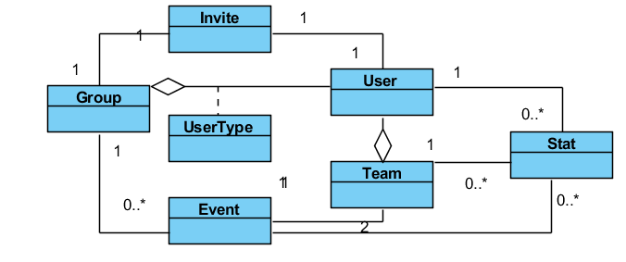
Figure 3 - Logical Structure simplified
The data descriptions of each of these data entities is as follows:

User Entity
Data Item | Type | Comment
Name | Text
Email Address | Text
UserName | Text
IsActive | Boolean
Group | Pointer | List
ProfilePicture | Pointer

Group Entity
Data Item | Type | Comment
ID | Integer
Name | Text
User | Pointer | List
Event | Pointer | List

UserType Entity
Data Item | Type | Comment
Group | Pointer
User | Pointer
Accepted | Boolean

Event Entity
Data Item | Type | Comment
ID | Integer
Name | Text
Date | Date
Location | Pointer
Group | Pointer
Team | Pointer | There are 2
Stat | Pointer | List

Team Entity
Data Item | Type | Comment
ID | Integer
Group | Pointer | May be several
Event | Pointer | Used for keyword search
Stat | Pointer | List

Stat Entity
Data Item | Type | Comment
ID | Integer
Type | Text
Value | Text
Group | Pointer | May be several
Event | Pointer | Used for keyword search
User | Pointer | List

3.3.2 Security

The server on which the JOGU resides will have its own security to prevent unauthorized write/delete access. There is no restriction on read access. The use of email by a user is on the client systems and thus is external to the system.
The control permissions between admins and users is also made client side

A. Appendices

A.1 Activity Diagram

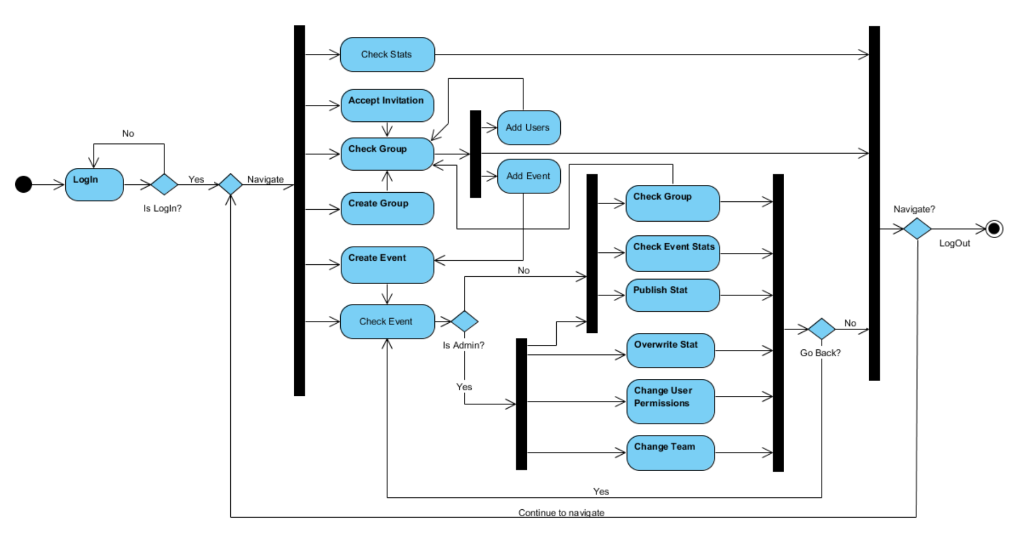
Figure 1 Activity Diagram

A.2 Class Diagram
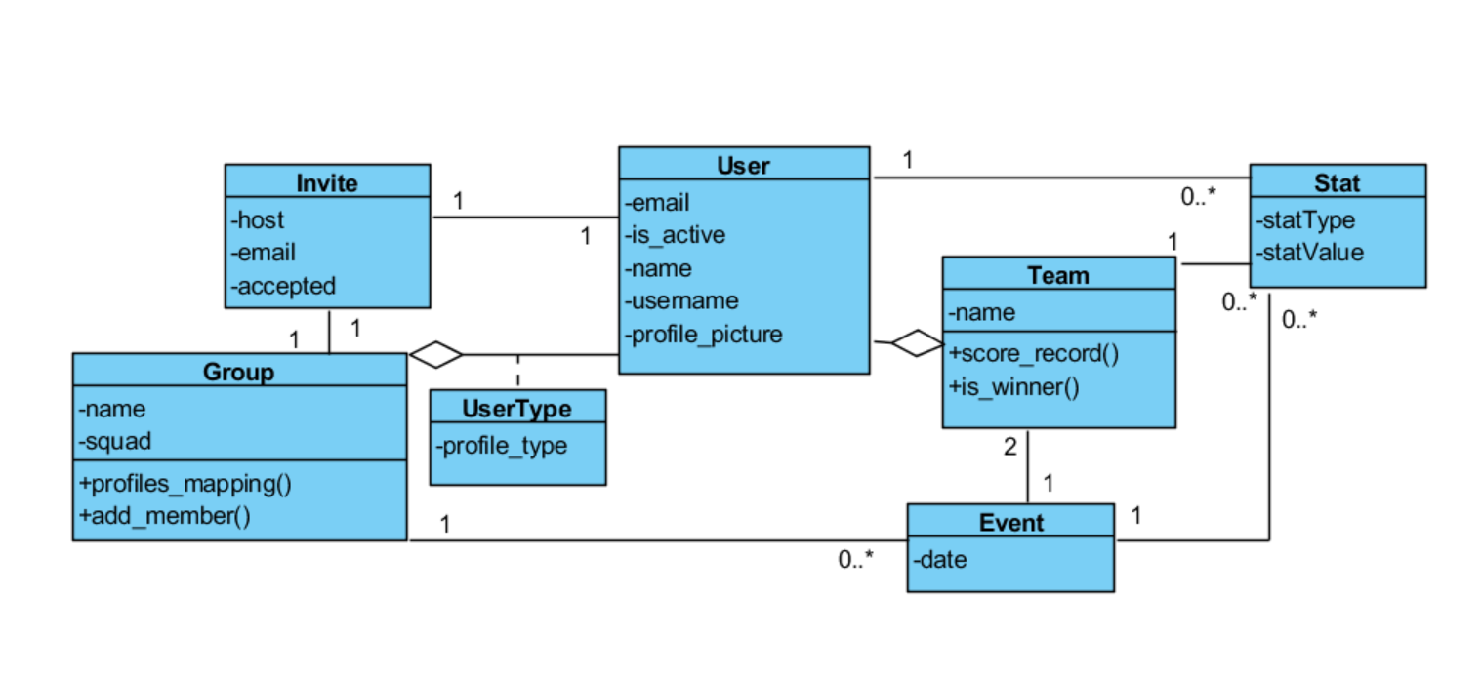
Figure 2 Class Diagram

A.3 State Diagram
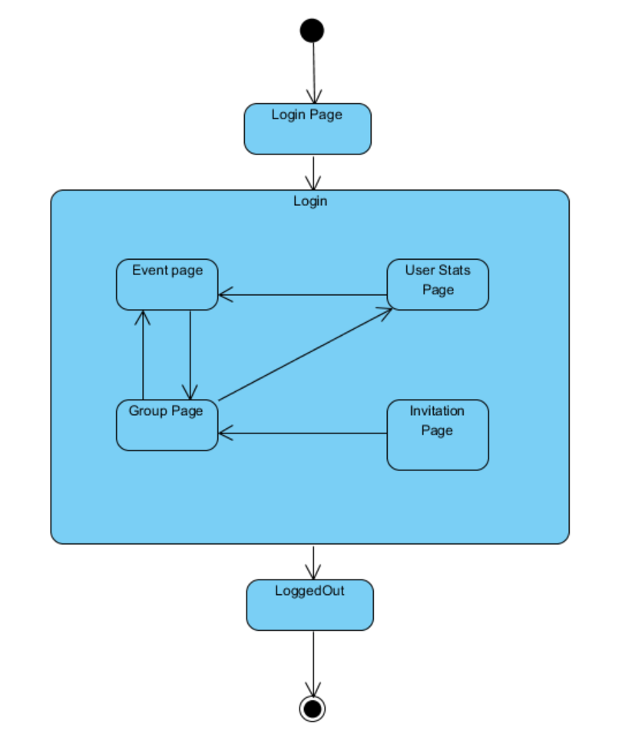
Figura 3 State Diagram

A.4 Dependency Matrix

Name of Use Case | Identifier | Date Created | Current Version | Author | Stability | Status | Origin/Source | Effort | Priority | Stakeholders | Dependcies
Login | US 2.3.1 | 10/11/2016 | 1.1 | José & Ricardo | stable | approved | P.O. | 13 | 1 | P.O./Users/Devs
Create an Event | US 2.3.2 | 11/11/2016 | 1.2 | José & Ricardo | changing | proposed | P.O. | 21 | 3 | P.O./Users/Devs | US 2.3.1 + US 2.3.3
Create a Group | US 2.3.3 | 11/11/2016 | 1.2 | José & Ricardo | changing | proposed | P.O. | 8 | 2 | P.O./Users/Devs | US 2.3.1
Consult an event | US 2.3.4 | 10/11/2016 | 1.1 | José & Ricardo | stable | approved | P.O. | 8 | 4 | P.O./Users/Devs | US 2.3.2
Accepts invitation | US 2.3.5 | 10/11/2016 | 1.1 | José & Ricardo | stable | approved | P.O. | 13 | 6 | P.O./Users/Devs | US 2.3.2
Publish stat | US 2.3.6 | 10/11/2016 | 1.1 | José & Ricardo | stable | approved | P.O. | 13 | 7 | P.O./Users/Devs | US 2.3.2
Overwrite | US 2.3.7 | 10/11/2016 | 1.1 | José & Ricardo | stable | approved | P.O. | 8 | 9 | P.O./Users/Devs | US 2.3.2 + US 2.3.6
Change user permission | US 2.3.8 | 10/11/2016 | 1.1 | José & Ricardo | stable | approved | P.O. | 8 | 10 | P.O./Users/Devs | US 2.3.2
Change team | US 2.3.9 | 10/11/2016 | 1.1 | José & Ricardo | stable | approved | P.O. | 8 | 5 | P.O./Users/Devs | US 2.3.2
Check stats | US 2.3.10 | 10/11/2016 | 1.1 | José & Ricardo | stable | approved | P.O. | 8 | 8 | P.O./Users/Devs | US 2.3.6

A.5 Requirements and their attributes
Name of Use Case | Identifier | Date Created | Current Version | Author | Stability | Status | Origin/Source | Effort | Priority | Stakeholders | Dependcies
Login | US 2.3.1 | 10/11/2016 | 1.1 | José & Ricardo | stable | approved | P.O. | 13 | 1 | P.O./Users/Devs
Create an Event | US 2.3.2 | 11/11/2016 | 1.2 | José & Ricardo | changing | proposed | P.O. | 21 | 3 | P.O./Users/Devs | US 2.3.1 + US 2.3.3
Create a Group | US 2.3.3 | 11/11/2016 | 1.2 | José & Ricardo | changing | proposed | P.O. | 8 | 2 | P.O./Users/Devs | US 2.3.1
Consult an event | US 2.3.4 | 10/11/2016 | 1.1 | José & Ricardo | stable | approved | P.O. | 8 | 4 | P.O./Users/Devs | US 2.3.2
Accepts invitation | US 2.3.5 | 10/11/2016 | 1.1 | José & Ricardo | stable | approved | P.O. | 13 | 6 | P.O./Users/Devs | US 2.3.2
Publish stat | US 2.3.6 | 10/11/2016 | 1.1 | José & Ricardo | stable | approved | P.O. | 13 | 7 | P.O./Users/Devs | US 2.3.2
Overwrite | US 2.3.7 | 10/11/2016 | 1.1 | José & Ricardo | stable | approved | P.O. | 8 | 9 | P.O./Users/Devs | US 2.3.2 + US 2.3.6
Change user permission | US 2.3.8 | 10/11/2016 | 1.1 | José & Ricardo | stable | approved | P.O. | 8 | 10 | P.O./Users/Devs | US 2.3.2
Change team | US 2.3.9 | 10/11/2016 | 1.1 | José & Ricardo | stable | approved | P.O. | 8 | 5 | P.O./Users/Devs | US 2.3.2
Check stats | US 2.3.10 | 10/11/2016 | 1.1 | José & Ricardo | stable | approved | P.O. | 8 | 8 | P.O./Users/Devs | US 2.3.6

Identifier – the id of the specific requirement this must be a unique.
Date Created – when the requirement was created.
Current Version – Last version that this requirement was modified.
Author – the name of the user or class of user that raised the requirement.
Status – this should indicate the stage at which the requirement; verified; approved; deleted; implemented; and rejected.
Priority – this should indicate the priority in relation to other requirements.
Effort – the effort of this requirement in relation to the success of the project.
Stability – the likelihood to the requirement changing for instance mature; stable; or still changing.
Stakeholders – the stakeholders that should be involved should any change requests be made that impact this requirement

